**Module 10 – Single Page Application framework – React**

**6.ReactJS-HOL**

**Explain the need and benefits of React Router**  
React Router is used in React applications to enable navigation between different views or components without reloading the entire page. Since React is a Single Page Application (SPA) framework, we need a way to update the view based on the URL. React Router helps us do that efficiently.

**Benefits of React Router:**

* Provides client-side routing
* Allows navigation without page reload
* Enables dynamic and nested routing
* Improves user experience by making the app faster and more interactive
* Allows bookmarking and deep linking to specific routes

**Identify the Components in React Router**  
The main components in React Router include:

1. BrowserRouter – Wraps the app and keeps UI in sync with the URL using HTML5 history API.
2. Routes – Groups multiple Route elements.
3. Route – Matches the URL and renders the associated component.
4. Link – Replaces <a> tag to navigate between routes without reloading.
5. NavLink – Similar to Link, but highlights the active link.
6. useParams() – Hook to access route parameters.
7. useNavigate() – Hook to navigate programmatically.

**List the types of Router Components**

1. BrowserRouter – Used in most web apps for clean URLs.
2. HashRouter – Uses # in the URL; good for static file hosting.
3. MemoryRouter – Stores the history in memory; used in testing or non-DOM environments.
4. StaticRouter – Used in server-side rendering like in Next.js.

**Parameter passing via URL**  
We can pass parameters in the URL using : syntax in the route path and retrieve them using the useParams() hook.

**Example:**

<Route path="/trainer/:id" element={<TrainerDetail />} />

If we visit /trainer/2, the id will be 2.

Inside the component:

const { id } = useParams();

This allows us to use the id to fetch or display the specific trainer's data

**Structure:**

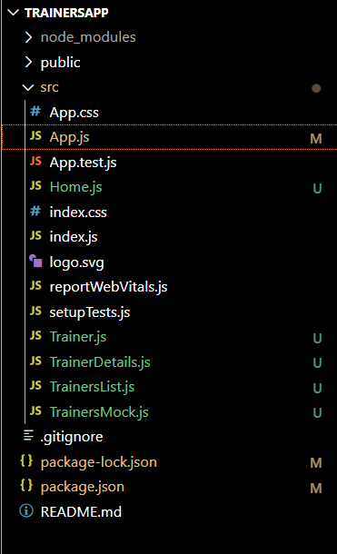

**App.js:**

import React from 'react';

import { BrowserRouter as Router, Routes, Route, Link } from 'react-router-dom';

import Home from './Home';

import TrainersList from './TrainersList';

import TrainerDetail from './TrainerDetails';

import trainers from './TrainersMock';

function App() {

  return (

    <Router>

      <div style={{ border: "1px solid black", padding: "10px", width: "500px" }}>

        <h2>My Academy Trainers App</h2>

        <nav>

          <Link to="/" style={{ marginRight: "10px" }}>Home</Link>

          <Link to="/trainers">Show Trainers</Link>

        </nav>

        <Routes>

          <Route path="/" element={<Home />} />

          <Route path="/trainers" element={<TrainersList trainers={trainers} />} />

          <Route path="/trainer/:id" element={<TrainerDetail />} />

        </Routes>

      </div>

    </Router>

  );

}

export default App;

**Trainer.js:**

class Trainer {

  constructor(trainerId, name, email, phone, technology, skills) {

    this.trainerId = trainerId;

    this.name = name;

    this.email = email;

    this.phone = phone;

    this.technology = technology;

    this.skills = skills;

  }

}

export default Trainer;

**TrainerDetails.js:**

import React from 'react';

import { useParams } from 'react-router-dom';

import trainers from './TrainersMock';

const TrainerDetail = () => {

  const { id } = useParams();

  const trainer = trainers.find(t => t.trainerId === parseInt(id));

  if (!trainer) return <p>Trainer not found.</p>;

  return (

    <div>

      <h3>{trainer.name}</h3>

      <p>{trainer.email}</p>

      <p>{trainer.phone}</p>

      <ul>

        {trainer.skills.map((skill, index) => (

          <li key={index}>{skill}</li>

        ))}

      </ul>

    </div>

  );

};

export default TrainerDetail;

**TrainersList.js:**

import React from 'react';

import { Link } from 'react-router-dom';

const TrainersList = ({ trainers }) => (

  <div>

    <h2>Trainers List</h2>

    <ul>

      {trainers.map((trainer) => (

        <li key={trainer.trainerId}>

          <Link to={`/trainer/${trainer.trainerId}`}>{trainer.name}</Link>

        </li>

      ))}

    </ul>

  </div>

);

export default TrainersList;

**TrainersMock.js:**

import Trainer from './Trainer';

const trainers = [

  new Trainer(1, "Syed Khaleelullah (.NET)", "khaleelullah@cognizant.com", "97676516962", ".NET", ["C#", "SQL Server", "React", ".NET Core"]),

  new Trainer(2, "Jojo Jose", "jojo@cognizant.com", "9123456789", "Java", ["Java", "Spring Boot"]),

  new Trainer(3, "Elisa Jones", "elisa@cognizant.com", "9876543210", "Frontend", ["HTML", "CSS", "JavaScript"]),

];

export default trainers;

**Output:**

